**SQL QUERIES WITH QUESTION**

1. **Change Id int emp_id**

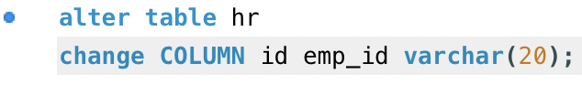

1. **Clean and format date data**

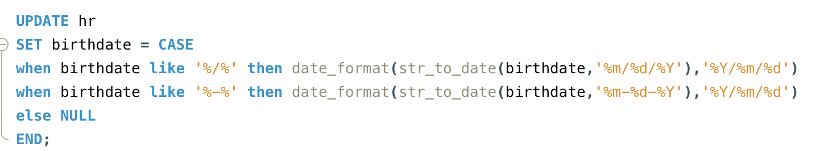

1. **Format termdate where empty spaces and nullified and other stamps show date**

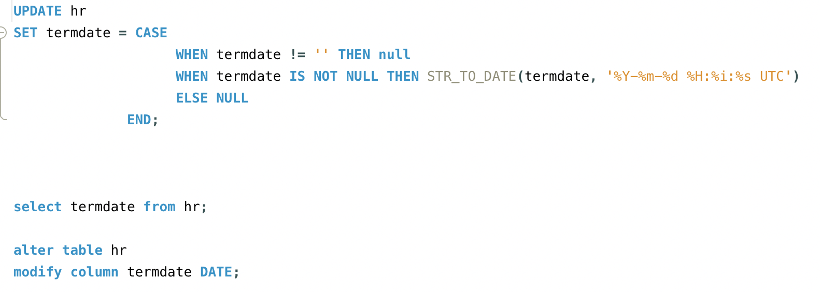

1. **Update birthdate_temp as age and calculate age**

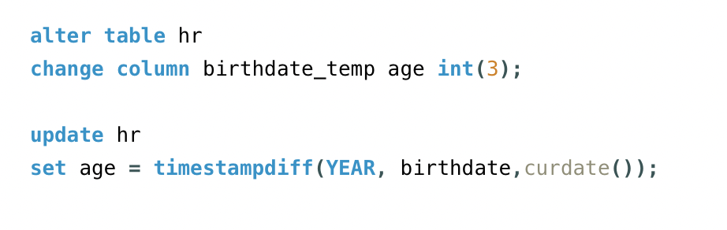

1. **Display the oldest and youngest person**

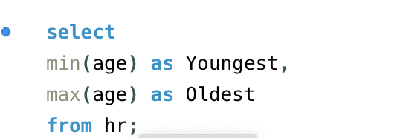

1. **Display number of people less than 18 years**

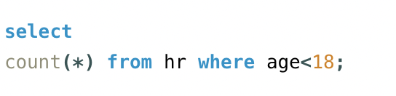

1. **Gender break down of the company**

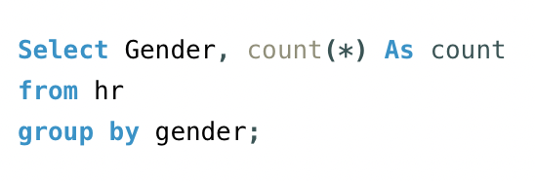

1. **Race/ethnicity breakdown**

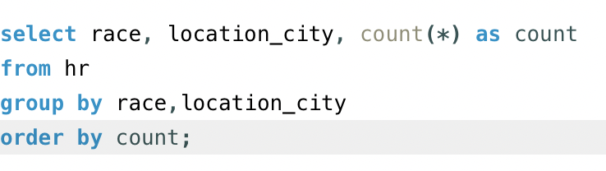

1. **Age distribution of employees**

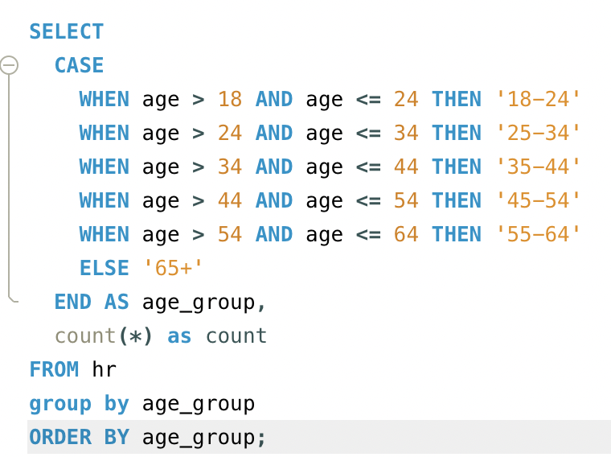

1. **How many people work in headquarters v/s remote**

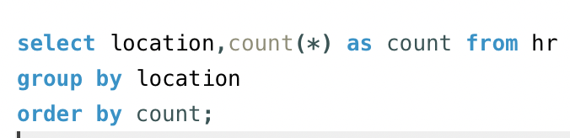

1. **Average of length of employees who have been terminated.**

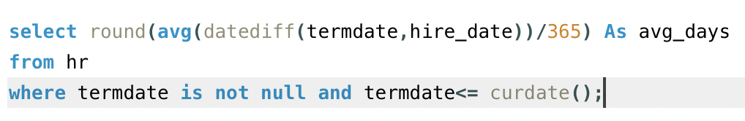

1. **Gender distribution across departments and job title**

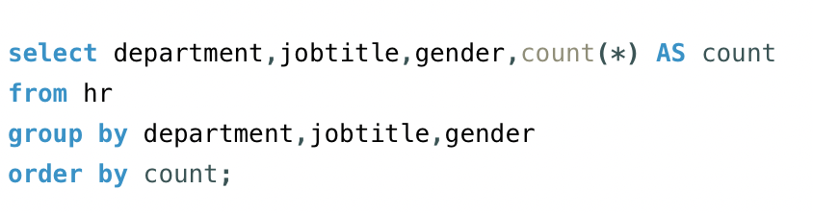

1. **Distribution of job titles across company**

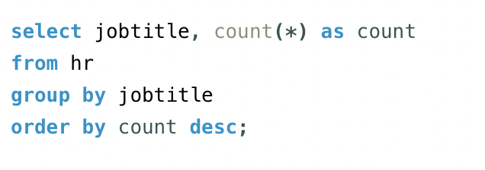

1. **Which company has highest termination rate.**

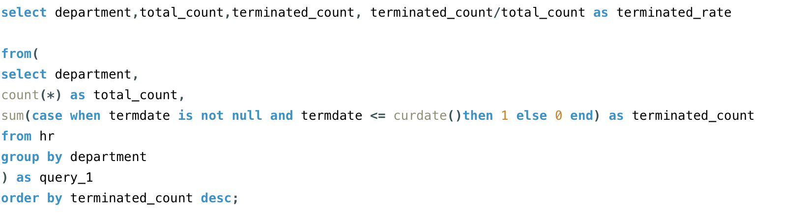

1. **Distribution of employees across state and locations**

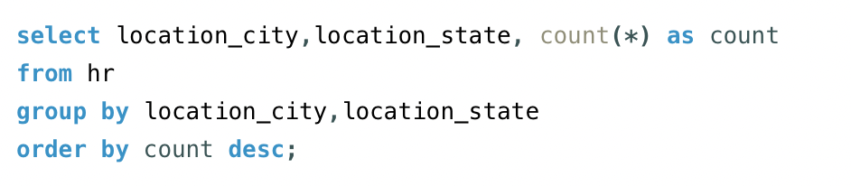

1. **How many employee count changed over the years based hire date and term dates**

